**Assignment – 3**

**Financial Analytics**

**Title : Analyzing competitive advantage in real companies**

**CONTENT**

* **Introduction**
* **Background**
* **Competitive advantage**
* **Financial performance evaluation**
* **Comparative analysis**
* **Assessment of sustainability**
* **Conclusion**

**In this task I am analysing the competitive advantage of two real companies operating in different industries. One company from technology sector i.e. MICROSOFT and another from the consumer goods sector i.e. PEPSICO.**

* **Introduction**
* **Company from technology sector :** **MICROSOFT**

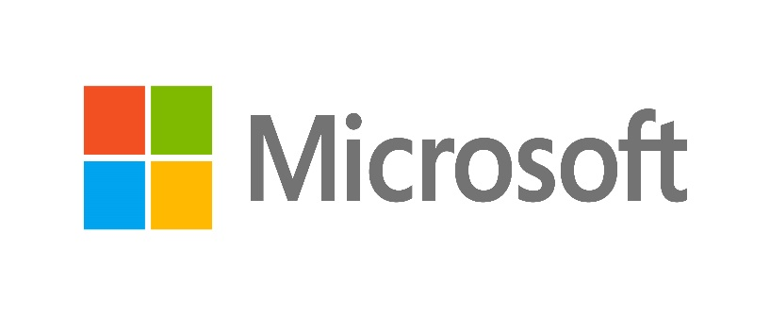

**Headquartered in Redmond, Washington, Microsoft Corporation is a prominent American multinational corporation and technology firm. Renowned for its Windows operating systems, Microsoft offers a range of software products, including the Microsoft 365 suite and the Edge web browser. Additionally, it manufactures popular hardware such as the Xbox gaming consoles and the Microsoft Surface line of touchscreen PCs. Notably, Microsoft secured the 14th position in the 2022 Fortune 500 rankings, based on total revenue, and Forbes Global 2000 recognized it as the world's leading software maker in the same year. Regarded as one of the Big Five American IT companies, Microsoft shares this distinction with Alphabet, Amazon, Apple, and Meta.**

* **Company from consumer goods sector** : **PEPSICO**

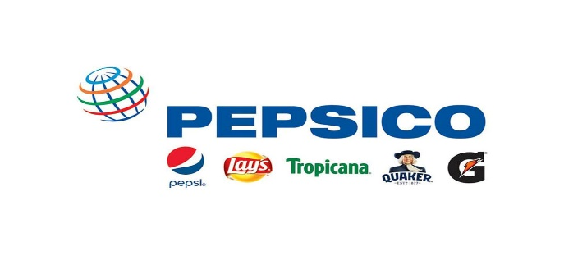

**PepsiCo, Inc. is an American multinational food, snack, and beverage corporation headquartered in Harrison, New York, in the hamlet of Purchase. PepsiCo's business encompasses all aspects of the food and beverage market. It oversees the manufacturing, distribution, and marketing of its products. PepsiCo was formed in 1965 with the merger of the Pepsi-Cola Company and Frito-Lay, Inc., PepsiCo has since expanded from its namesake product Pepsi Cola to an immensely diversified range of food and beverage brands. The largest and most recent acquisition was Pioneer Foods in 2020 for US$1.7 billion[2] and prior to it was buying the Quaker Oats Company in 2001, which added the Gatorade brand to the Pepsi portfolio and Tropicana Products in 1998.**

* **Background**

1. **Company name : Microsoft**

**Throughout the 1990s and early 2000s, Microsoft diversified its product portfolio, introducing iconic software such as Microsoft Office, which included popular applications like Word, Excel, and PowerPoint. The company also expanded into hardware with the launch of the Xbox gaming console in 2001, competing with established players in the video game industry.**

1. **Company name : Pepsico**

**The merger of these two companies formed PepsiCo, which quickly became one of the largest and most recognizable brands globally. PepsiCo's product portfolio expanded beyond soft drinks and snack foods to include a wide array of beverages, such as Gatorade, Tropicana, and Lipton, as well as food products like Quaker Oats, Lay's potato chips, Doritos, and Cheetos.**

* **Competitive advantages**

comparing competitive advantages of both the companies.

|  |  |  |
| --- | --- | --- |
| **Company name** | **MICROSOFT** | **PEPSICO** |
| **Brand** **recognition** **and trust** | **Microsoft** enjoys strong brand recognition and trust globally, stemming from its long history of providing reliable and innovative software solutions. | PepsiCo owns a wide range of popular brands across various categories, including beverages (Pepsi, Mountain Dew, Gatorade), snacks (Lay's, Doritos, Cheetos), and breakfast foods (Quaker Oats). This diverse portfolio allows PepsiCo to cater to different consumer preferences and capture market share across multiple segments. |
| **Enterprise Focus** | Microsoft has a strong foothold in the enterprise market with products like Microsoft Office, Dynamics 365, and Azure. Its enterprise-grade solutions, coupled with robust security features and compliance certifications, make Microsoft a preferred choice for businesses worldwide. | PepsiCo operates in over 200 countries and territories worldwide, providing it with a strong global footprint. This extensive reach enables PepsiCo to access diverse markets, adapt to regional preferences, and capitalize on emerging trends in different regions. |
| **Innovation and Research** | Microsoft invests heavily in research and development, driving innovation in areas such as artificial intelligence, mixed reality, and quantum computing. This focus on innovation ensures that Microsoft remains at the forefront of technological advancements. | PepsiCo invests significantly in research and development to introduce new products and improve existing ones. The company continuously innovates to meet changing consumer preferences, develop healthier options,and capitalize on emerging trends in the food and beverage industry |
| **Market leadership** | Microsoft is known for its innovative and impactful marketing campaigns that capture consumer attention and drive engagement. Whether it's the "I'm a PC" campaign for Windows, the "Empowering Us All" campaign for Microsoft Surface, or the launch events for new products and services, Microsoft's marketing efforts are creative, memorable, and effective. | PepsiCo is known for its innovative and impactful marketing campaigns that resonate with consumers worldwide. Iconic campaigns like the Pepsi Challenge and collaborations with celebrities and influencers have helped reinforce brand loyalty and drive consumer engagement. |
| **Distribution network** | Microsoft's distribution network advantages lie in its global reach, multi-channel approach, digital distribution capabilities, retail partnerships, enterprise sales focus, cloud services distribution, and developer ecosystem. These advantages enable Microsoft to efficiently deliver its products and services to customers worldwide and drive growth in the competitive technology market. | PepsiCo benefits from a robust distribution and supply chain network, allowing its products to reach consumers efficiently and effectively. The company's extensive network of distribution centers, bottling plants, and retail partnerships ensures widespread availability and accessibility of its products. |

* **Analysing financial performance**
* **Analysing financial performance of**

**Technology company : Microsoft**

1. **Revenue** : Microsoft reported **$198 billion** in revenue, showcasing an impressive **18% growth** compared to the previous year.
2. **Operating income : The company’s operating income reached $83 billion**

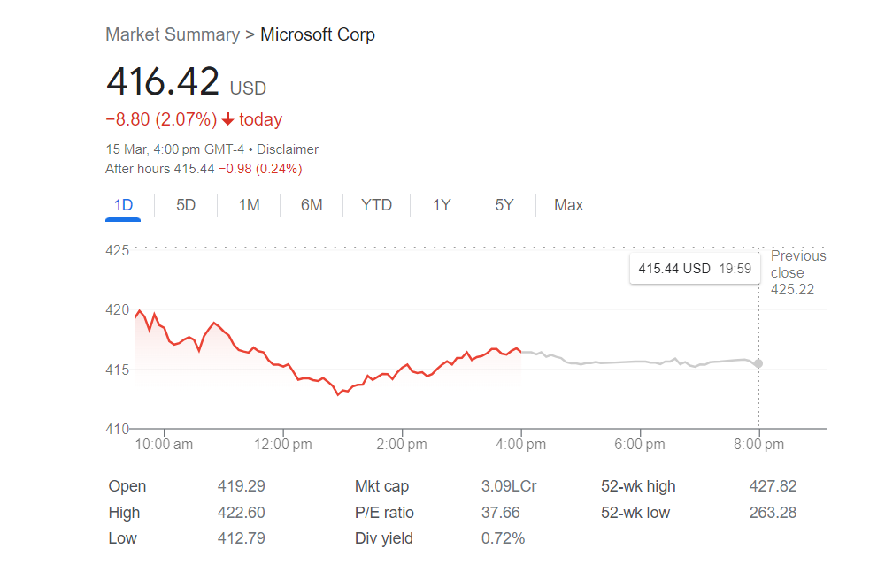

1. **Return on investment:**

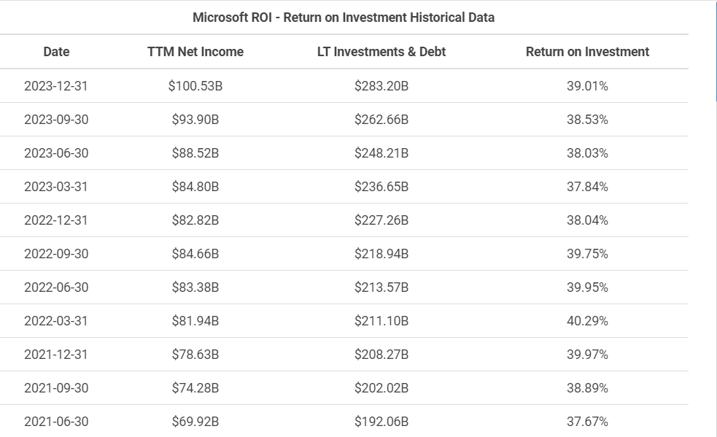

1. **Net income :** Microsoft **earned $72.7 billion** in net income, reflecting a **19% growth.**

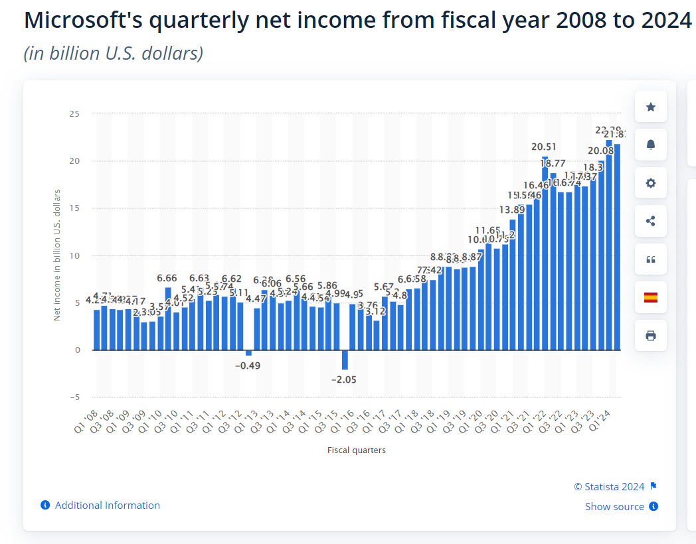

* **Analysing financial performance of**

**Consumer goods service company : pepsico**

1. **Revenue growth:**

The company has generated cash flow growth of 6.1%, and is expected to report cash flow expansion of 10.6% in 2024. PEP should be on investors' short lists because of its impressive growth fundamentals, a good Zacks Rank, and strong Growth and VGM Style Scores.

1. **Profit margin:**

Current and historical gross margin, operating margin and net profit margin for PepsiCo (PEP) over the last 10 years. Profit margin can be defined as the percentage of revenue that a company retains as income after the deduction of expenses. PepsiCo net profit margin as of December 31, 2023 is 9.92%.

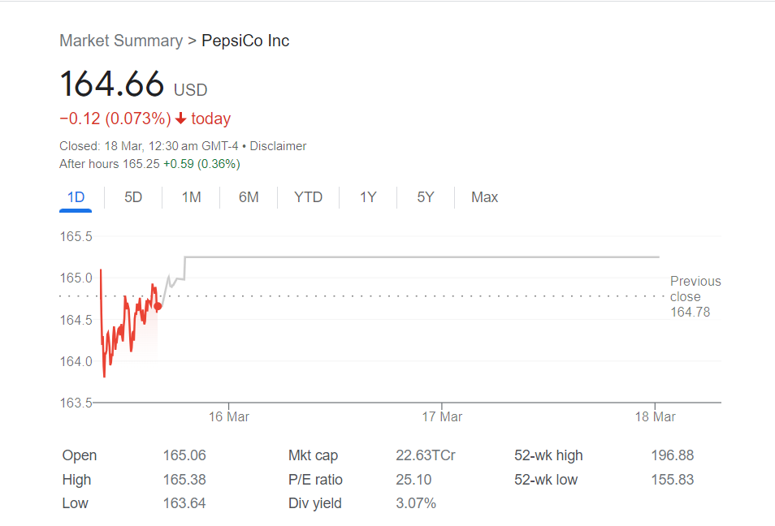

**Return on investment:**

PepsiCo's annualized return on invested capital (ROIC %) for the quarter that ended in Dec. 2023 was 10.68%. As of today (2024-03-17), PepsiCo's WACC % is 6.29%. PepsiCo's ROIC % is 12.83% (calculated using TTM income statement data).

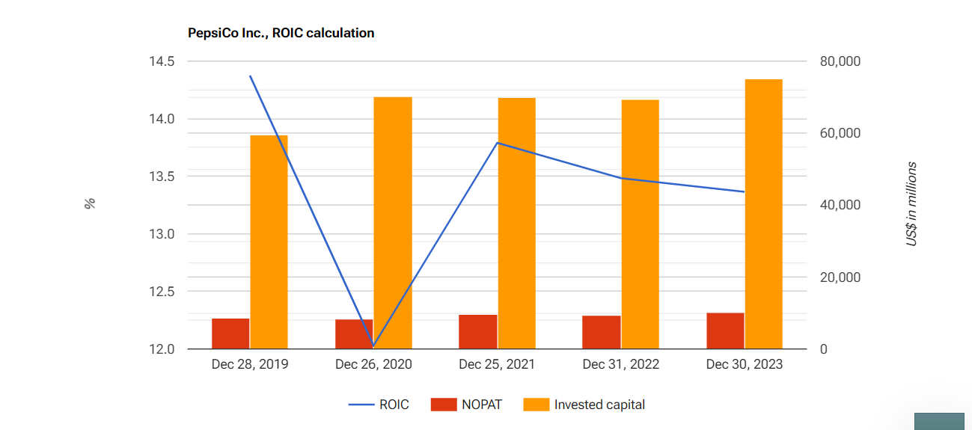

1. **Market share:**

Pepsi has been slowly losing market share in the carbonated soft drink category for years, standing at 8.9 percent in 2021. In the beverage segment, PepsiCo's main challenger has always been Coca-Cola. As a brand, Coca-Cola had a value of over five times that of Pepsi.

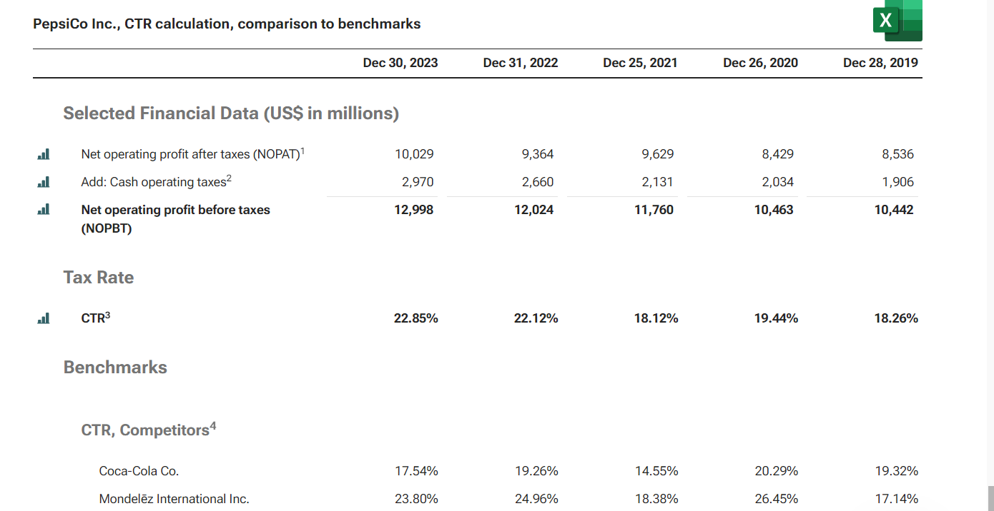

* **Compare competitive positions**

|  |  |  |
| --- | --- | --- |
| **Company name** | **Microsoft** | **Pepsico** |
| **Market share** | Microsoft is a top tech company with a 21% market share worldwide. In April 2023, Microsoft's market cap reached $2.254 trillion, showing its industry dominance. In FY2022, Microsoft was valued at $1.7 trillion, a 29.10% drop from its peak of $2.4 trillion in 2021. | Pepsi has been slowly losing market share in the carbonated soft drink category for years, standing at 8.9 percent in 2021. In the beverage segment, PepsiCo's main challenger has always been Coca-Cola. As a brand, Coca-Cola had a value of over five times that of Pepsi. |
| **Growth prospects** | Microsoft's growth probably won't cool off anytime soon. From fiscal 2023 to fiscal 2026, analysts expect its revenue and EPS to grow at CAGRs of 14% and 16%, respectively, as it continues to expand its cloud, AI, and gaming ecosystems. | PepsiCo is forecast to grow earnings and revenue by 9.4% and 4.5% per annum respectively. EPS is expected to grow by 9.8% per annum. Return on equity is forecast to be 50.8% in 3 years. |
| **Competitive threats** | Threats. Intensifying Competition and Market Disruption: The technology industry is marked by fierce competition and the constant threat of disruptive innovations. Microsoft must contend with competitors that are rapidly developing new products and services, particularly in the cloud and AI spaces. | PepsiCo also faces several threats that can impact its business and financial performance. Here are a few key threats: Intense competition: The food and beverage industry is highly competitive, with several established players and new entrants. This can lead to price wars and erode profitability. |
| **Barriers to entry** | Microsoft's market share is so dominant, the barrier has a similar effect within the market: It prevents Intel-compatible PC operating systems other than Windows from attracting significant consumer demand, and it would continue to do so even if Microsoft held its prices substantially above the competitive. | For many years, the rest of the world has assumed that India's governing body is a closed minded regime, avoiding outside investments almost entirely, especially consumer good. This was an obvious obstacle for both Coca-Cola and Pepsi Co. |

* **Assessment of sustainability**

Sustainability assessment requires an evaluation of present and future conditions to show that present decisions and actions are not compromising future human and ecological health and well-being.

1. Technology company: **Microsoft**

To conduct a sustainability assessment for Microsoft, we need to evaluate both present actions and future implications to ensure that the company's decisions align with the goal of maintaining human and ecological well-being over time. Here's how we can approach it:

Microsoft has committed to becoming carbon negative by 2030, meaning it aims to remove more carbon from the atmosphere than it emits. The company plans to achieve this through carbon reduction initiatives, renewable energy investments, and carbon offset programs.

Microsoft has made significant investments in renewable energy, aiming to power its data centers and operations with 100% renewable energy. The company has entered into power purchase agreements (PPAs) for renewable energy and invests in new clean energy projects.

1. Consumer goods sector: **pepsico**

# That's What I Like”

To conduct a sustainability assessment for PepsiCo, we need to evaluate its present actions and future implications to ensure that the company's decisions align with the goal of maintaining human and ecological well-being over time.

PepsiCo's current environmental footprint, including its carbon emissions, water usage, waste generation, and energy consumption. Evaluate the company's progress toward reducing its environmental impact through initiatives such as energy efficiency improvements, renewable energy adoption, and sustainable sourcing practices.

a comprehensive sustainability assessment for PepsiCo should evaluate both present actions and future implications across environmental, social, and governance dimensions. By considering the long-term consequences of its decisions and actions, PepsiCo can ensure that it is not compromising future human and ecological health and well-being and is actively contributing to a more sustainable future for all.

* **Conclusion**

1. **Microsoft**

In conclusion, Microsoft demonstrates a strong commitment to sustainability across environmental, social, and governance dimensions. The company's proactive approach to reducing its environmental impact, promoting diversity and inclusion, and upholding high standards of governance positions it as a leader in corporate sustainability. Microsoft's efforts to address present challenges while considering future implications underscore its dedication to maintaining human and ecological well-being over time. By continuing to innovate, collaborate, and invest in sustainable practices, Microsoft is poised to drive positive change and contribute to a more sustainable future for all stakeholders.

1. **Pepsico**

PepsiCo has made significant strides in advancing sustainability across its operations, demonstrating a strong commitment to environmental stewardship, social responsibility, and corporate governance. The company's efforts to reduce its environmental footprint, promote diversity and inclusion, and engage with communities underscore its dedication to long-term sustainability and positive societal impact. PepsiCo's initiatives not only address present challenges but also consider future implications, ensuring that the company's decisions and actions are aligned with the goal of maintaining human and ecological well-being over time. By continuing to innovate, collaborate, and invest in sustainable practices, PepsiCo is well-positioned to drive positive change and contribute to a more sustainable future for generations to come.

***

**Name : M.Triveni**

**College : DR. Lankapalli Bullayya College**